**Operating System Lab**

**Windows 10 Installation Manual**

1. Search “Download windows 10” on your browser.

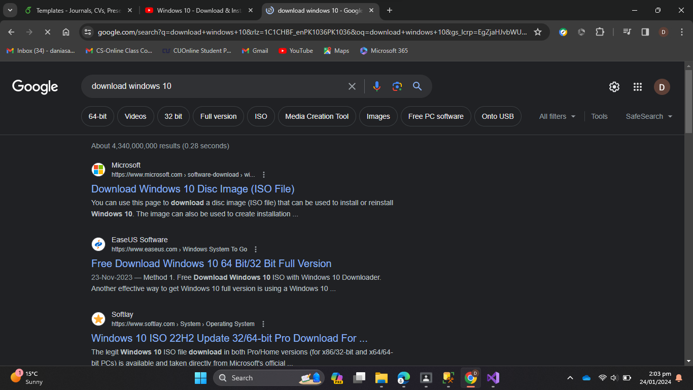

1. Click on the second link.

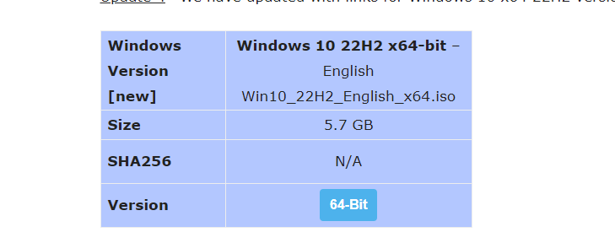

1. Download 64 bit Windows 10 ISO file.

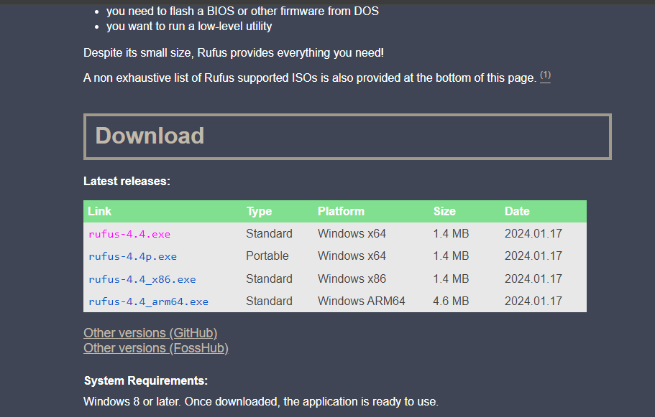

1. Download Rufus to make Windows 10 Bootable USB From ISO.

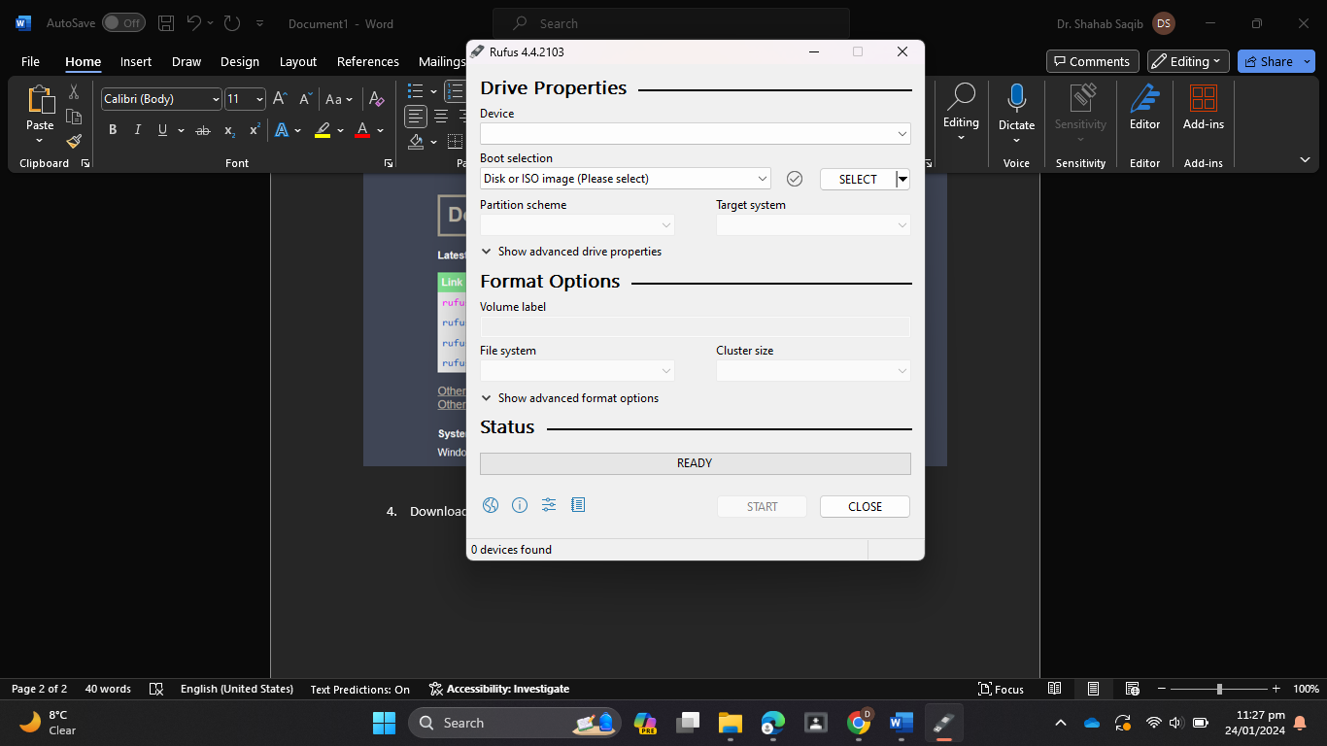

5.After downloading run it and select the ISO File previously downloaded.

6. After entering the desired information click on start and the USB will be ready to be used as a bootable USB(make sure your USB is previously empty).

7. Attach the USB to the Laptop you want to install the windows in.

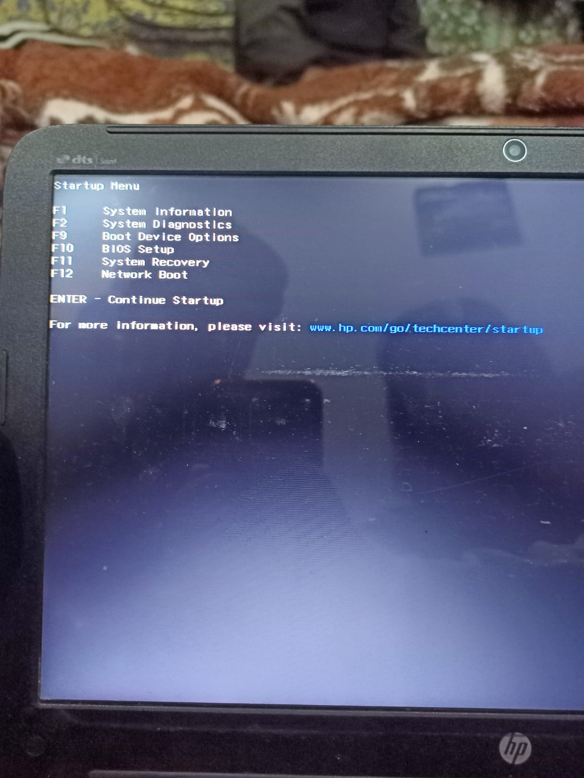

8. Press F9.

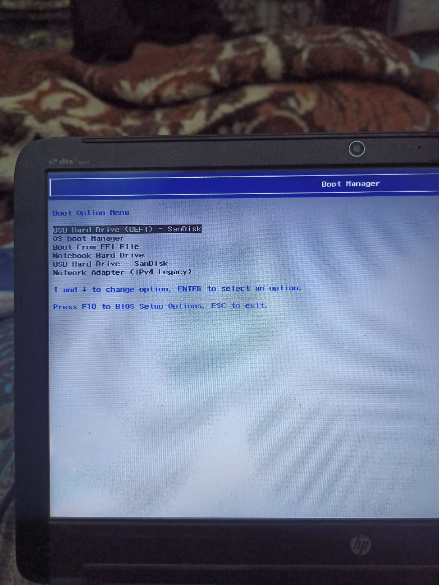

9. Select your USB to boot.

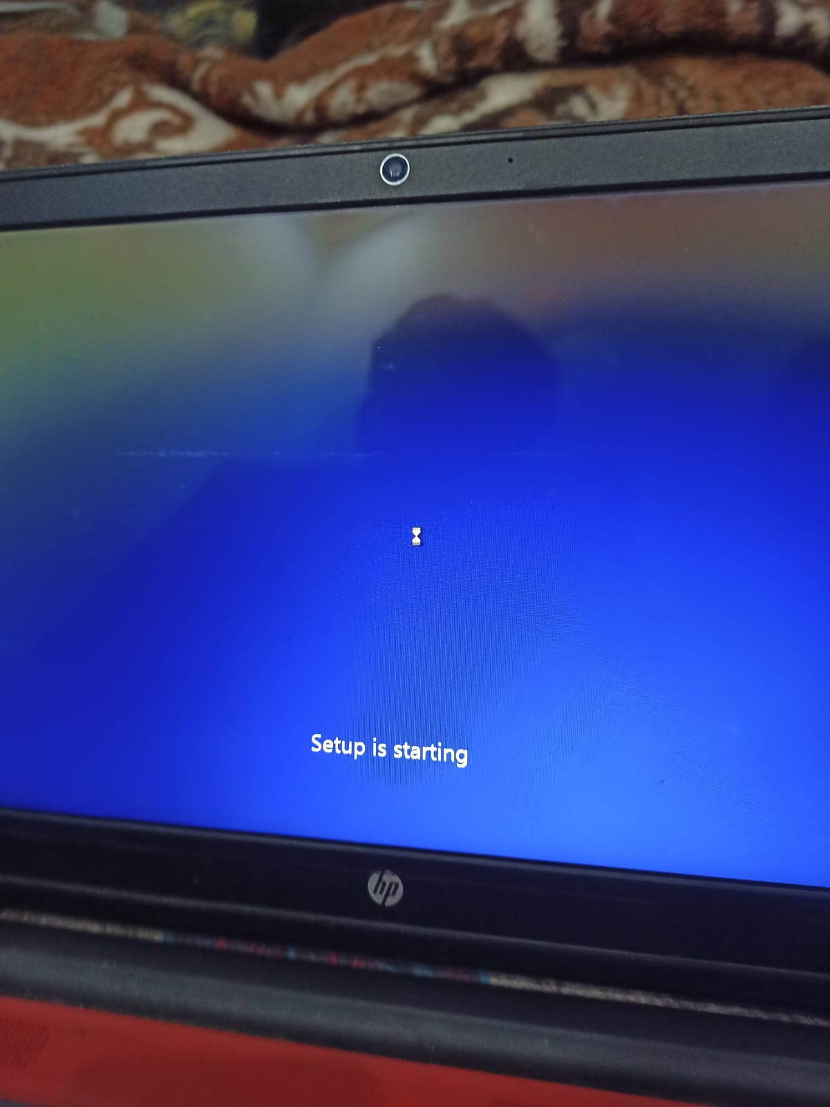

10. It starts to boot.

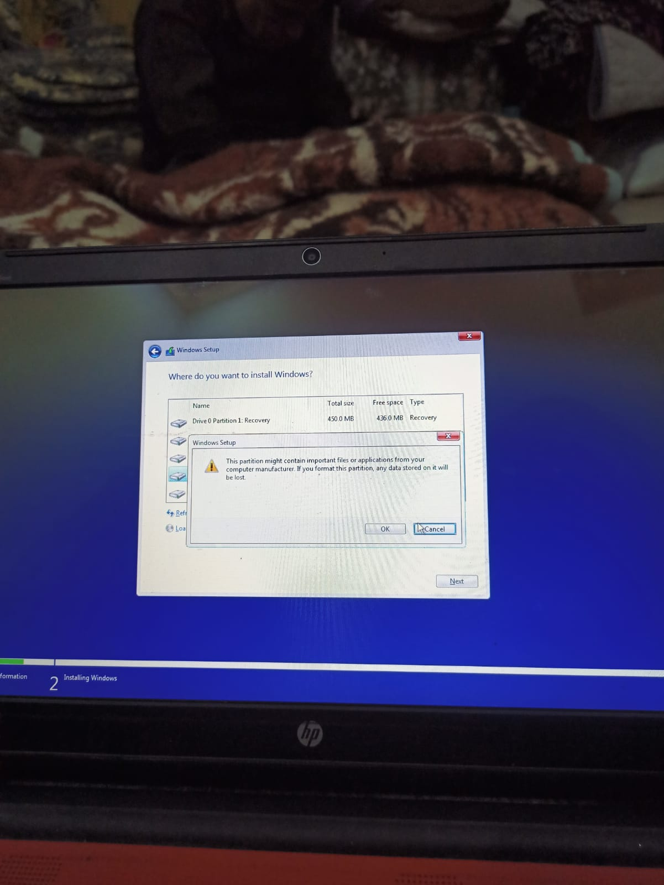

11. Select where do you want to install your windows in this device.

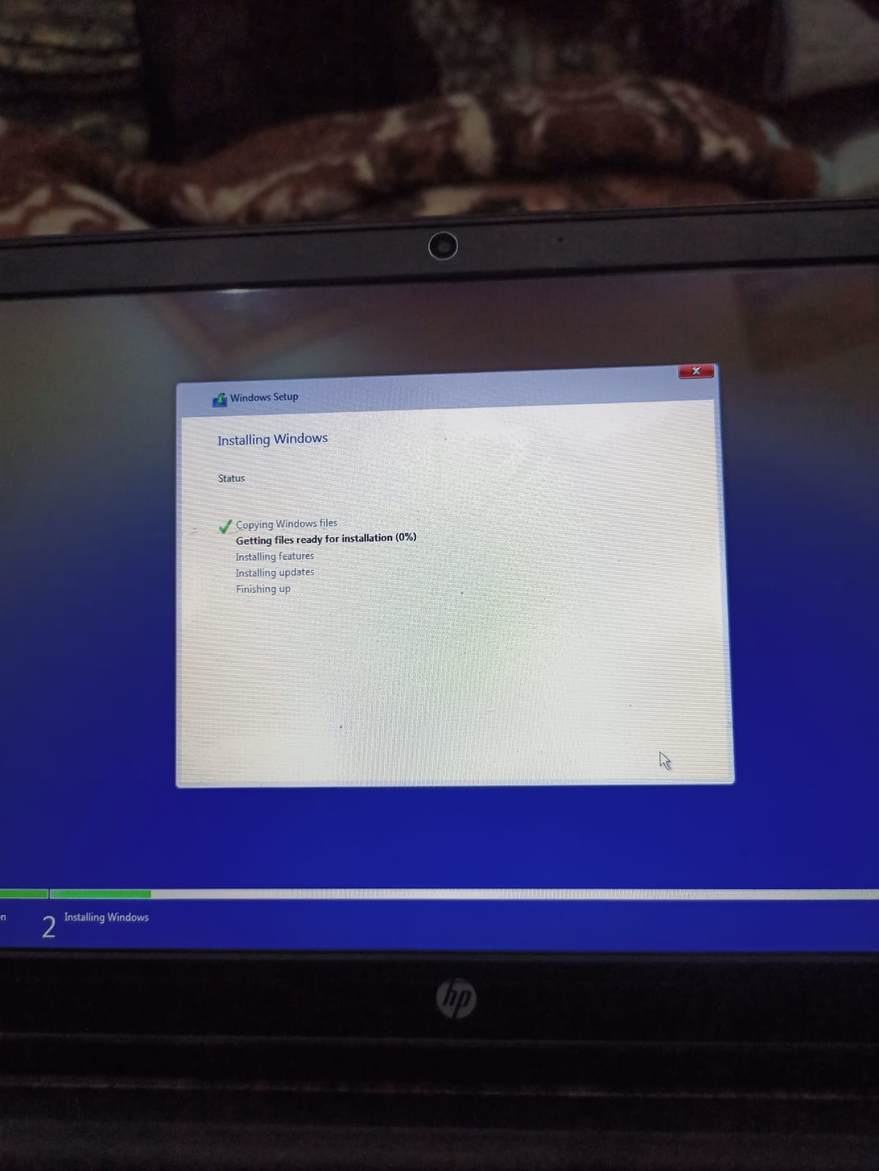

12. Wait for the windows installation.

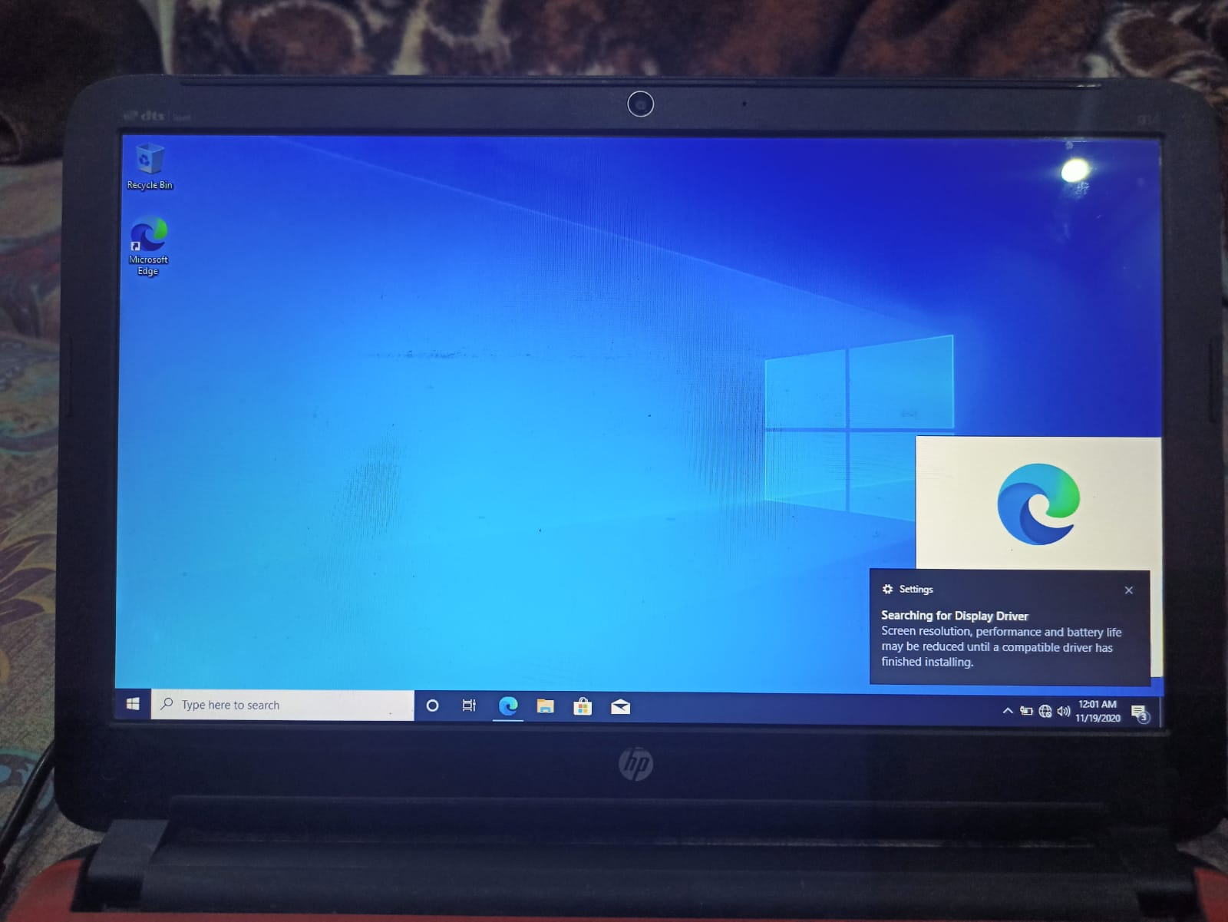

13. Windows successfully installed.